AIRe Talk User Manuals
Version 1.1
27.2.2026

Table of Contents
Table of Contents 2
AIRe Talk 3
Create an account 4
Check-in 6
Home 8
Main Menu 9
Conversation history 12
Your own content library 13
User account 16
Settings 20
About AIRe 21
Discussion 22
Other features 28

AIRe Talk

AIRe is an AI-assisted application that helps the user identify rehabilitation needs and guides them individually to rehabilitation services and content.
Please note that AIRe is not a medical diagnostic tool.

AIRe Talk is the user interface of the AIRe platform. To use AIRe, you need to create a personal user account and log in to AIRe Talk.

Create an account
When you open AIRe in a web browser, the start page opens (Figure 2). A pop-up window will open on top of the site, which will be used to select the default language of the user interface (Figure 1).

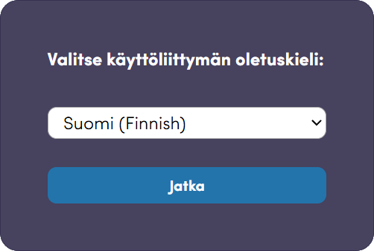
Figure 1 – Selecting the default user interface language

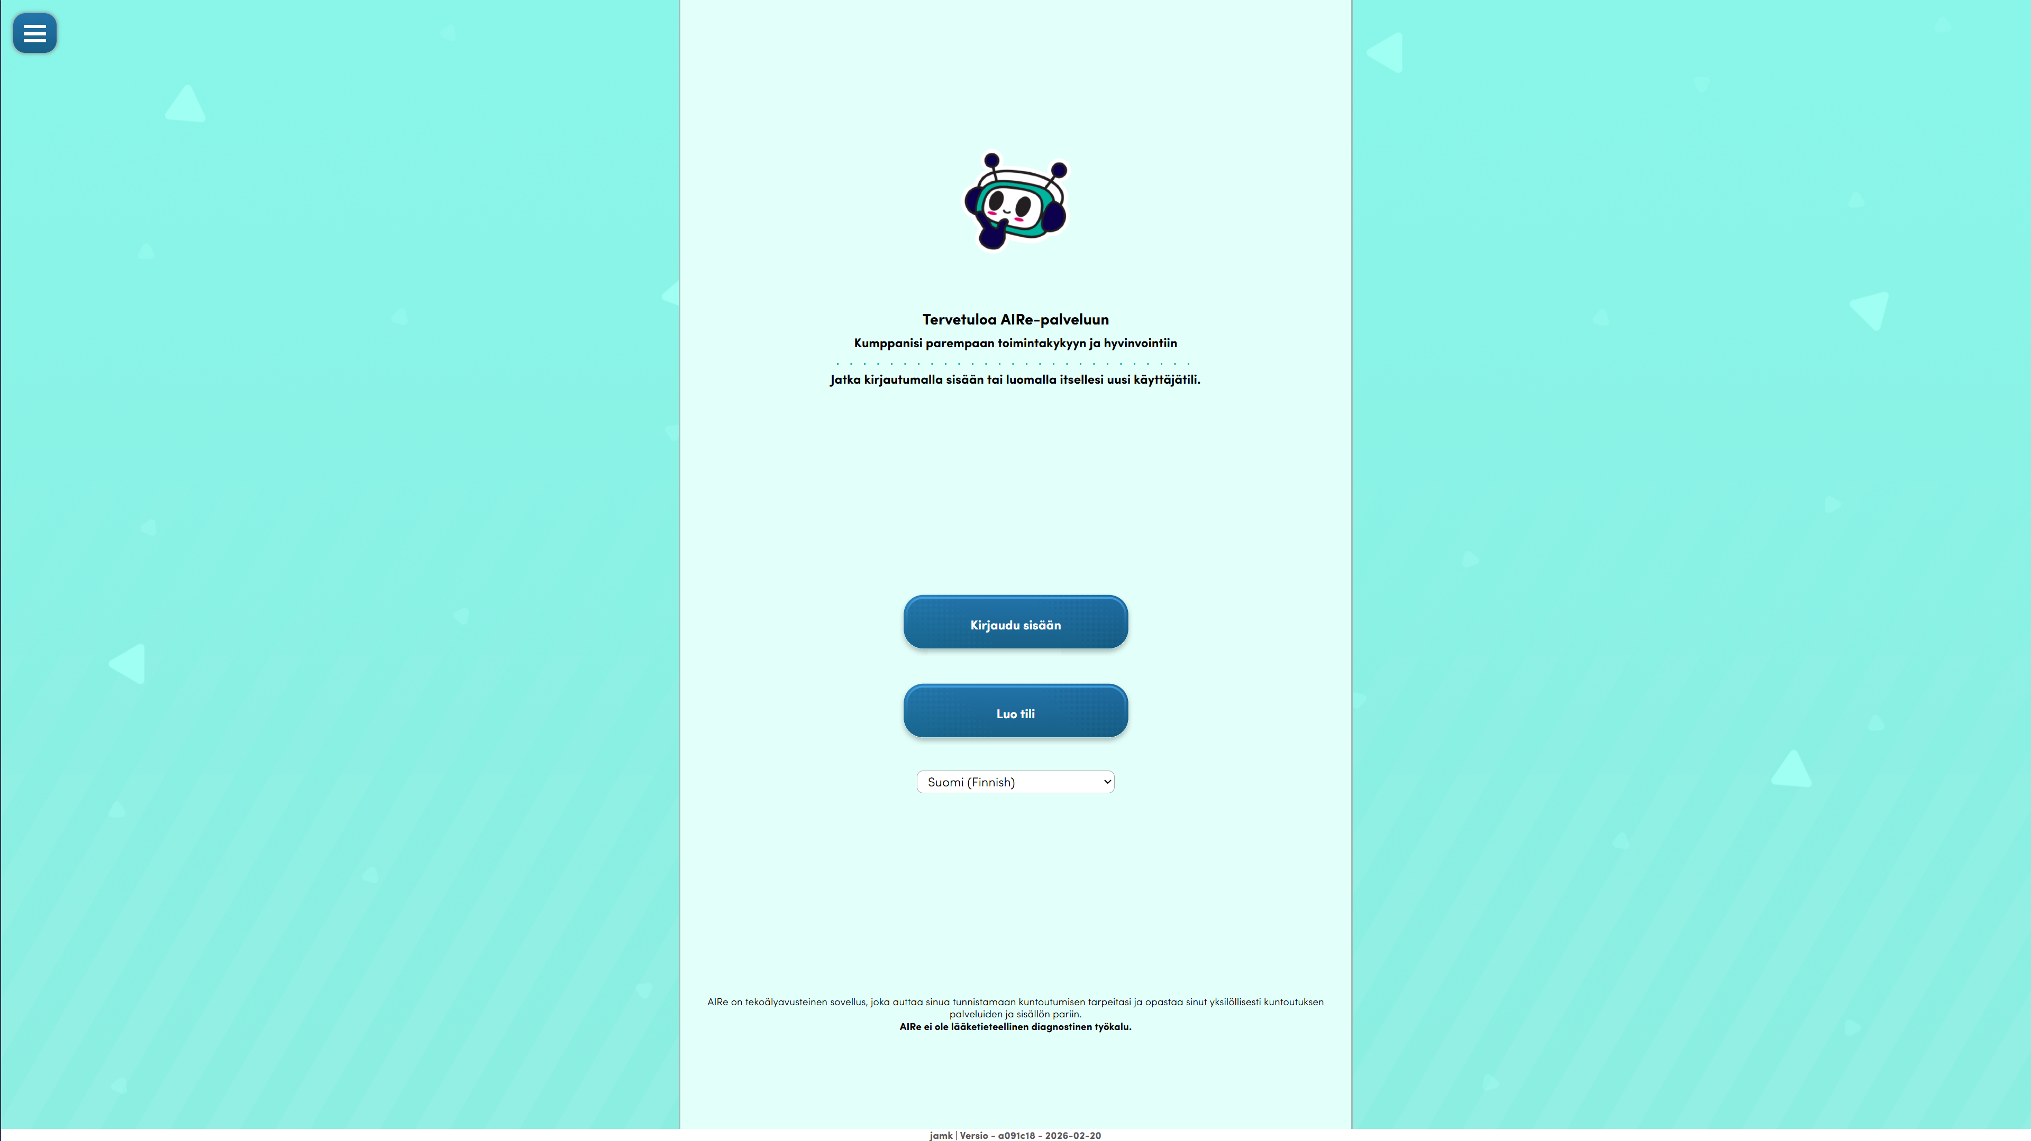
Figure 2 – Landing Page
Home
- Log in
  - Log in to the AIRe service with your user account.
- Create an account
  - Create your own user account.
- Language selection
  - Select the language you want to use AIRea in.

When you click on the "Create account" button on the home page, the account creation view opens (Figure 3).
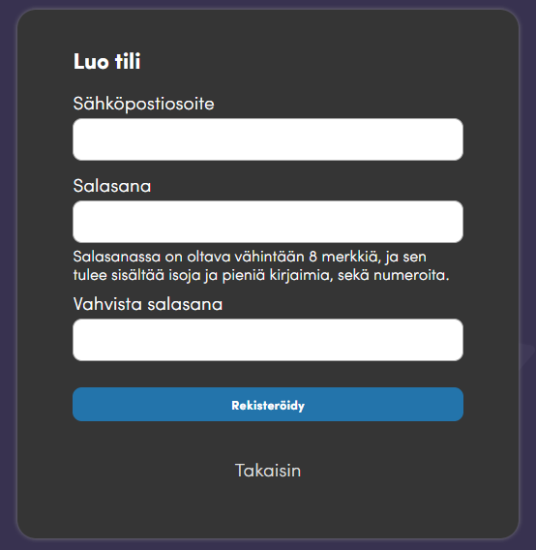
Figure 3 - Create an account

Create an account
- Email address
  - Enter a valid email address.
- Password
  - Enter a unique password.
  - The password must be at least 8 characters long.
  - The password must contain uppercase and lowercase letters, as well as numbers.
- Confirm password
  - Re-enter the password.
  - This will help ensure that there are no typos in the password.
- Register
  - Once the requested information has been filled in, press "Register" to create an AIRe account.
  - You will receive an email from AIR with a six-digit verification code.
  - Enter the verification code in AIRe to complete the account creation.

Check-in
Once the user account has been created, you can log in to AIRRE using the email address and password you used to register for the service (Figure 4).
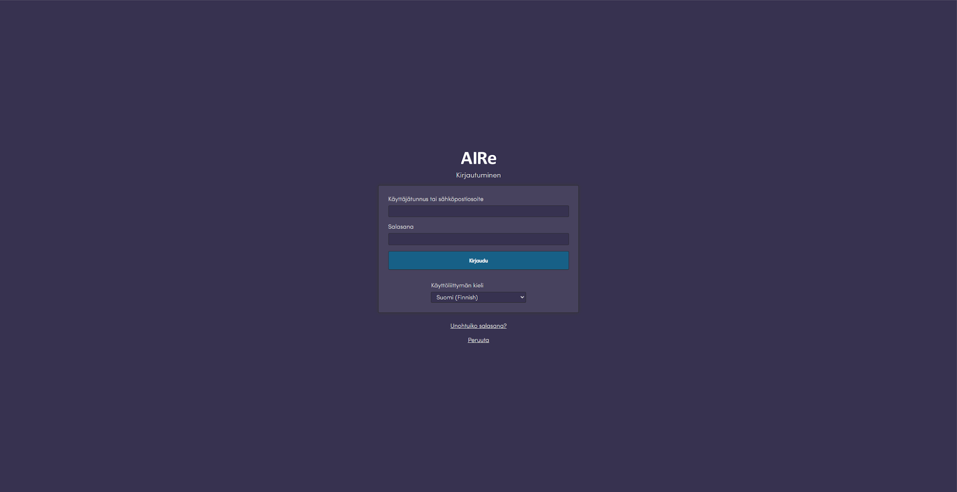
Figure 4 - Login

Check-in
- Username or email address
  - Enter the email address you used to register for AIRe.
- Password
  - Enter your AIRe account password.
- Log in
  - Once the username and password have been entered, you can log in to the service by pressing the "Login" button.
- User interface language
  - Select your preferred user interface language.
  - The languages to choose from are: Finnish, English, Spanish, Vietnamese, Indonesian, Swahili and Rwanda.
- Forgot your password?
  - If you have forgotten your password, you can reset it.
  - AIRe will send you an emailwith instructions on how to change your password.
- Cancel
  - Cancel the sign-in.

When you press the "Login" button and the username and password you entered are correct, the login confirmation screen opens (Figure 5).
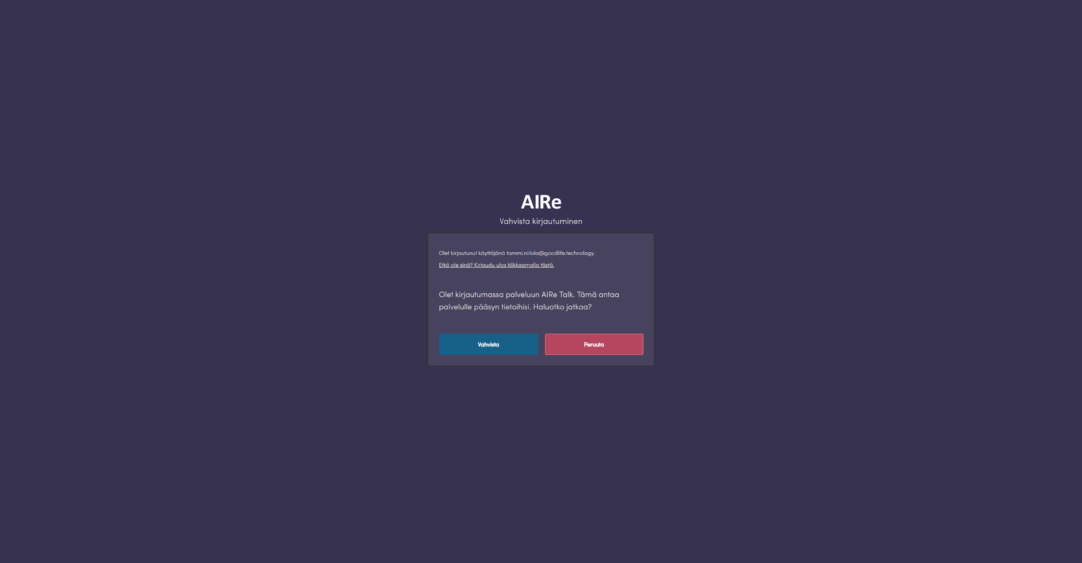
Figure 5 - Confirm login

Confirm login
- Confirm
  - Confirm the login.
- Cancel
  - If you are logging in with the wrong account, press "Cancel" and log out of the service.

Home

After logging in, the AIRE front page opens.
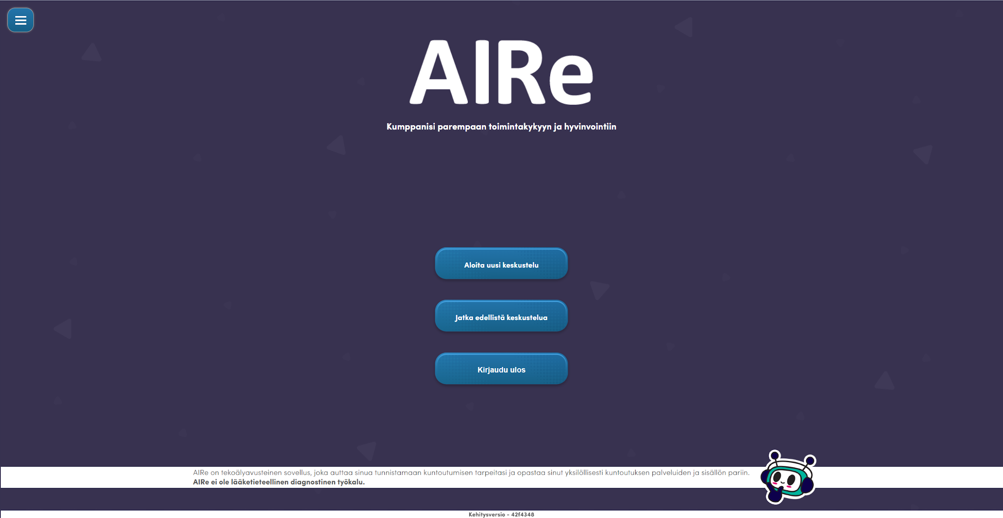
Figure 6 - Home

Home
- Start a new conversation
  - You can start a new conversation with AIRRE.
- Continue previous discussion
  - You can continue the previous conversation with AIRe.
- Log Out
  - Logs out of AIRRE.
Bottom bar
- The bottom bar contains information about the AIRe instance to be used
  - The name of the instance.
  - Tag hash for the current version
  - Date of creation of the current version

Figure 7 – Bottom Bar

Main Menu

Open the main menu by pressing the icon in the upper left corner of the screen (Fig. 8).


Figure 8 - Side Menu Icon

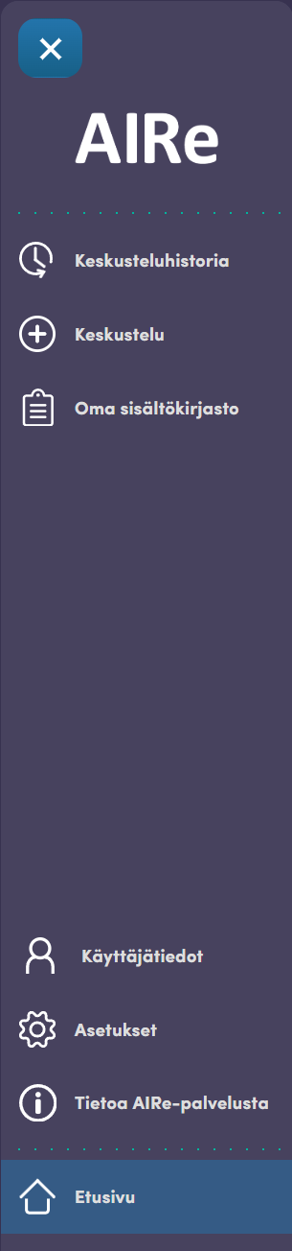
Figure 9 – Main Menu

Main Menu
- Conversation history
  - Here you can find all your previous conversations with AIRRE.
- Discussion
  - Start a new conversation with AIRe.
- Your own content library
  - Here you will find all the content suggested to you by AIRe.
- User information
  - Your user profile.
  - You can edit your own information here.
- Settings
  - AIR's settings.
- About AIRe
  - Read more about the AIRe service.
- Home
  - Go back to the front page of AIR by clicking this button.

Conversation history

In the conversation history, you can see all your previous conversations with AIRRE (Figure 10). To return to a previous conversation, click the conversation of your choice. You can also delete the conversation by pressing the trash can icon.
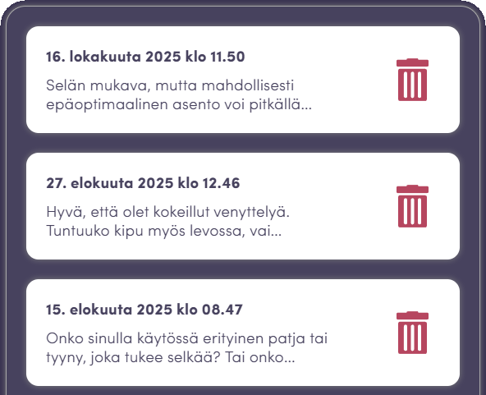
Figure 10 – Conversation history

Your own content library

AIRe can suggest content on the topic you discussed with it. All suggested content is saved in your own content library (Figure 11). From there, you can view the suggested content or return to the discussion where the content was suggested.
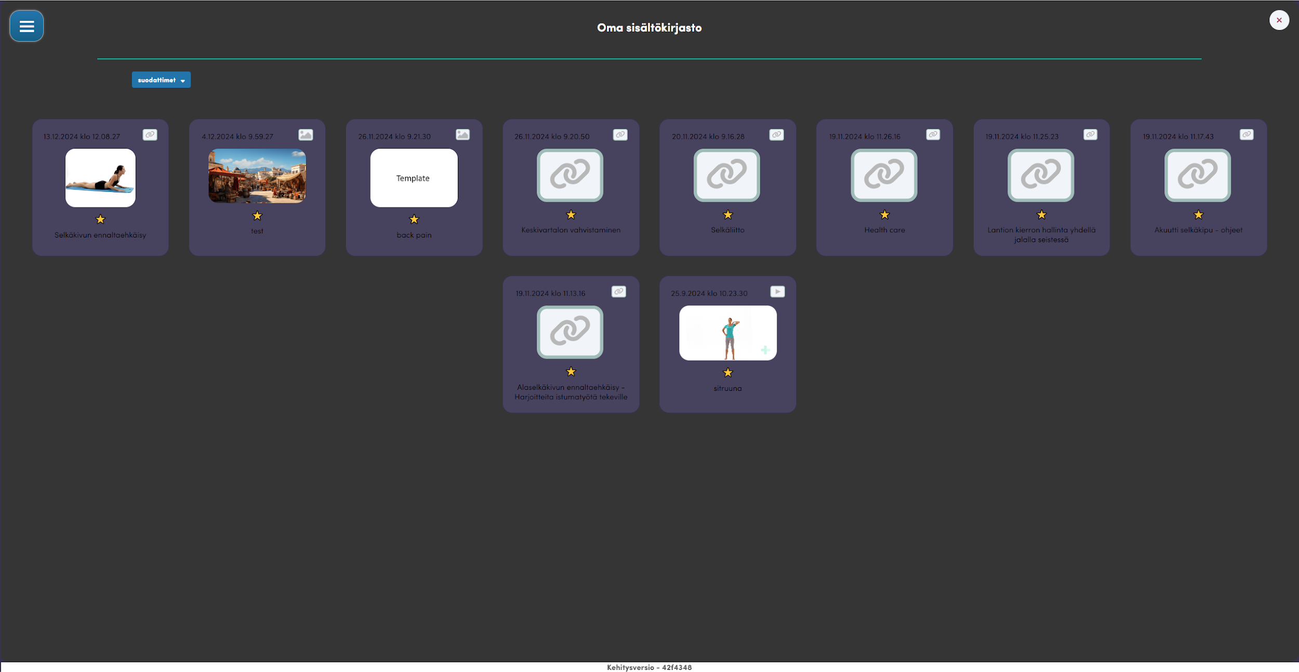
Figure 11 - My Content Library

You can click on the content box to see the content and more detailed information (Figure 12). Depending on the content, you can view it directly in AIRE or click on a link that redirects you to an external site where the actual content is located.
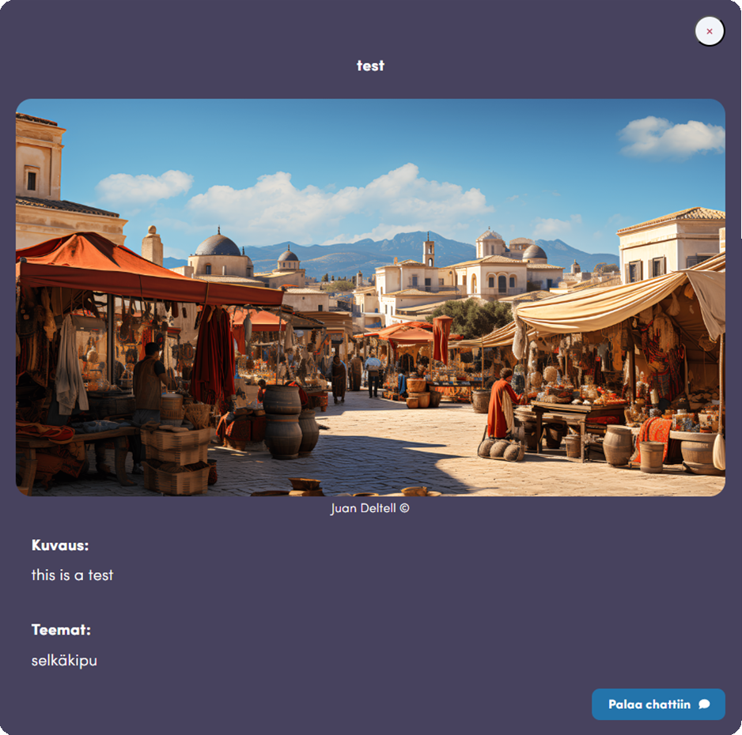
Figure 12 - Image content example

Clicking on the "Filters" button will open a view where you can filter the displayed content (Figure 12).
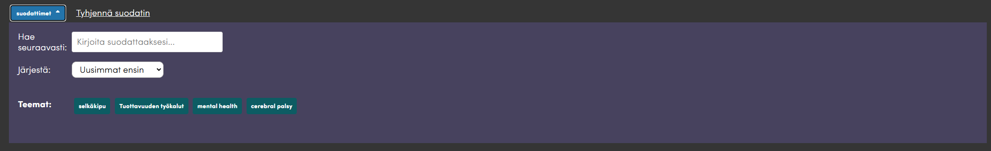
Figure 13 – Content Filters

Content filters
- Clear the filter
  - Clears all filter selections.
- To apply, follow these steps
  - You can enter the text you want to filter the content.
- Organize
  - Choose how you want your content to be organized.
- Themes
  - You can choose the themes that you want to see content for.
  - This will show the content that is linked to that theme.

User account

Under User information, you can view and edit your user account settings (Figure 14). In the discussions, AIRe also asks for some of this information and is able to update it with the information obtained from the discussions.
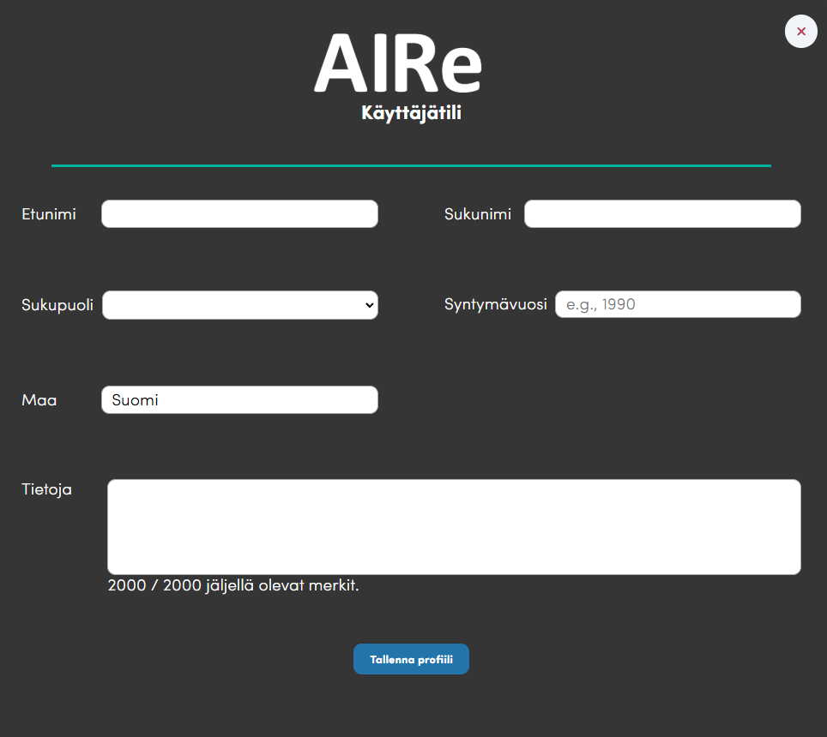
Figure 14 – User Profile
User Profile
- First name
- Last name
- Gender
- Year of birth
- Earth
- About
  - Here you can write more information about yourself. AIRe takes the information into account in conversations with you.
- Save profile
  - Save the changes made to the user profile.
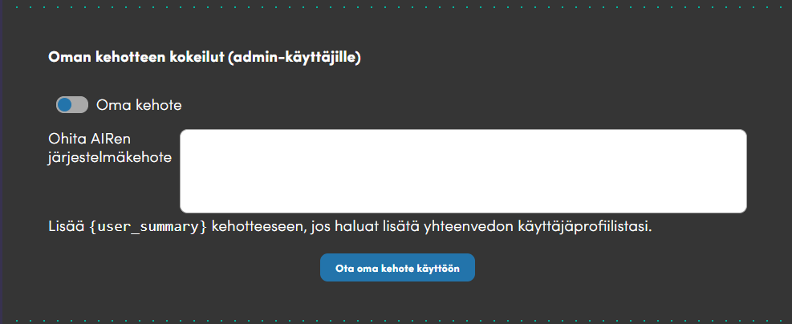
Figure 15 – Experimenting with your own prompt
My prompt experiments are for admins only. In this case, part of the system prompt used by AIRE can be replaced with its own prompt (Figure 15).

Custom prompt experiments
- My prompt
  - A button to determine whether to use your own prompt.
- Ignore AIRe's system prompt
  - Enter your own system prompt here.
- Enable My Prompt
  - Once you have entered your own system prompt, press this button to enable it.

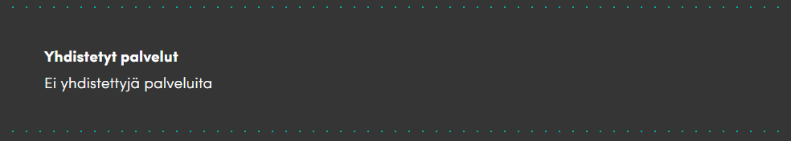
Figure 16 - Connected services

Under Connected services, you will see a list of the services to which your AIRe account is connected (Figure 16).

Change password
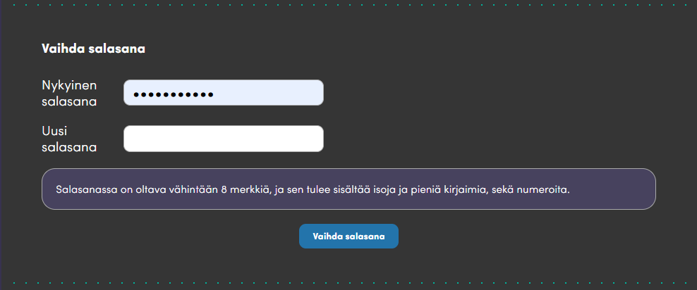
Figure 17 – Change Password

You can change the password of your AIRe account by entering the old password and the new password (Figure 17).

Personal information
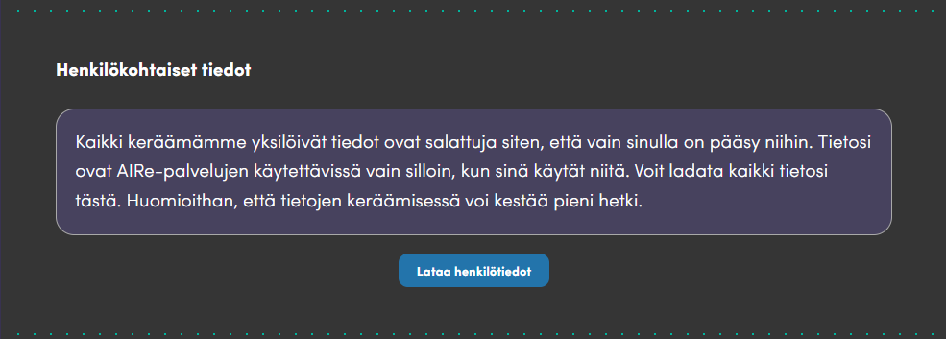
Figure 18 – Personal Information

You can download all the data collected by AIRe about yourself by clicking the "Download personal data" button (Figure 18).

Delete your account
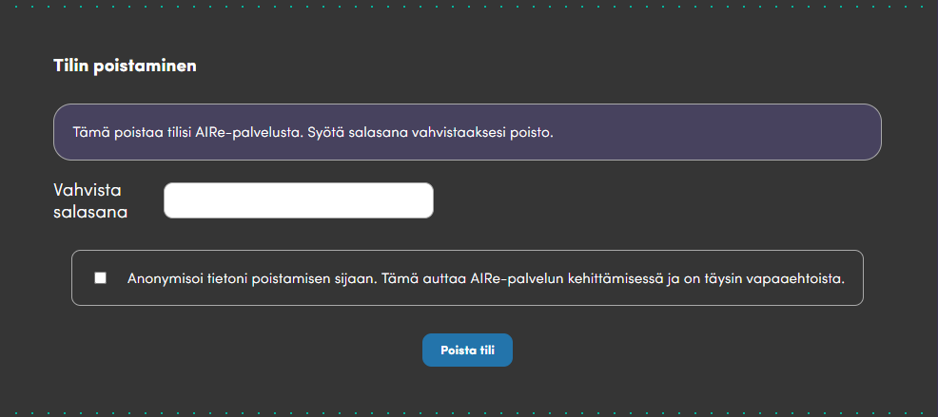
Figure 19 – Account Deletion
You can delete your AIRe account by entering your own password and pressing the "Delete account" button (Figure 19).

You can also choose to have your data anonymised and used in the future in the development and research use of the AIRe service. This is completely voluntary and can be chosen by the user. Any information from which the user can be identified will either be changed or deleted.

Chat history tokens
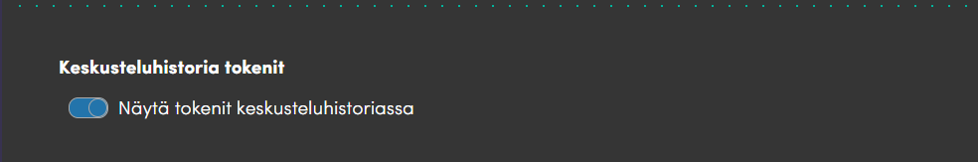
Figure 20 - Chat History Tokens

You can choose whether the chat history shows the number of tokens in the conversations (Figure 20).
In the context of artificial intelligence, tokens are the smallest units from which artificial intelligence models text. They can be words, parts of words, or individual characters such as spaces or punctuation marks. For example, the phrase "Hello world!" can be divided into tokens such as "Hello," "world," and "ma!" This sharing helps the AI process and understand text efficiently, as it analyzes and predicts next tokens when building responses or generating text.

Settings

In the settings of Airre, you can select some things that are part of the user interface (Figure 21).

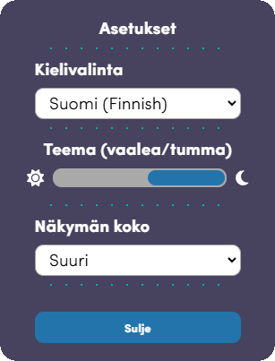
Figure 21 – Settings
Settings
- Language selection
  - The user interface language to use.
- Theme
  - Light or dark UI theme.
- View size
  - This setting scales the UI either to normal size or slightly larger.
- Close
  - Closes the settings menu.

About AIRe


Figure 22 - Information about AIRe services

Here you can find information about AIRe services (Figure 22).
- Terms of Use
- Privacy Policy

Discussion
The actual functionality of AIRRe can be found in discussions. The user can chat with generative AI in the AIRe service (Figure 23).
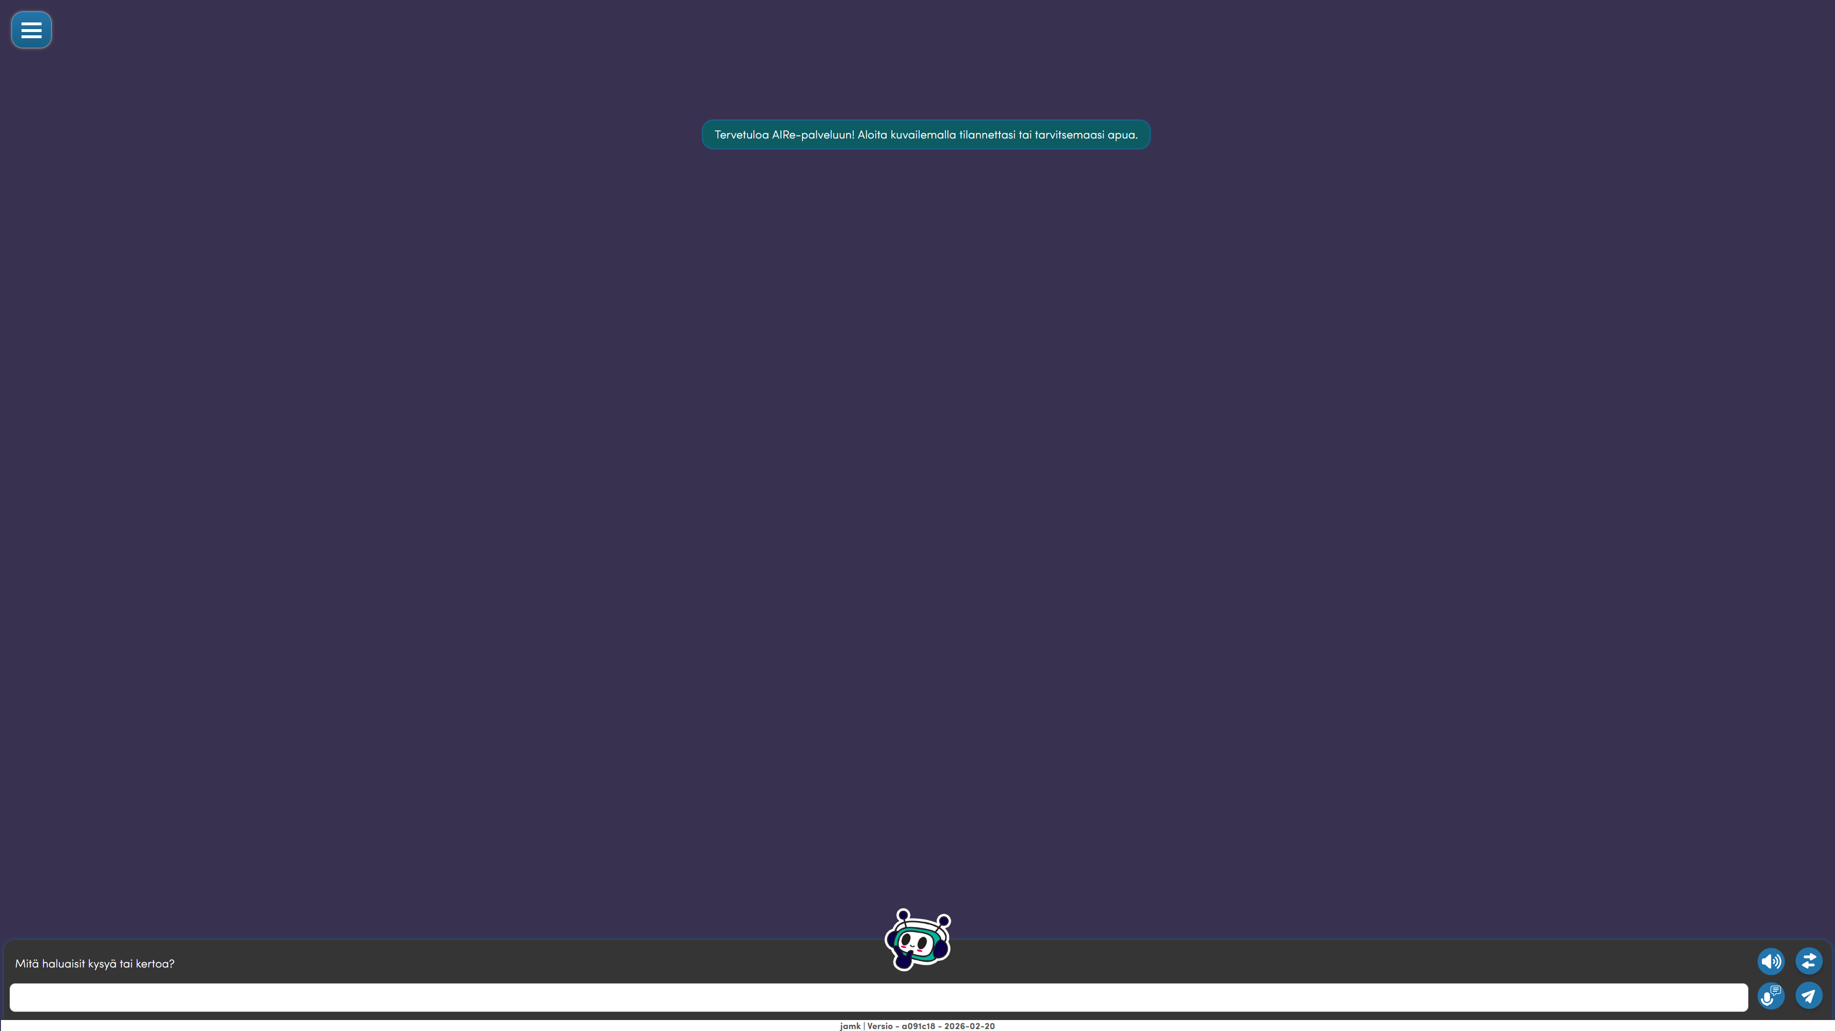
Figure 23 - Conversation view

The conversation takes place by typing a message in the text field (Figure 24).

Figure 24 – Discussion interface

You can also speak your message into the microphone by pressing the "Start Speech Recognition" icon (Fig. 25). When you want to stop Speech Recognition, press the Speech Recognition icon again. This feature doesn't work in all browsers. If your browser doesn't support the feature, the speech recognition icon will be hidden.

Figure 25 – Start Speech Recognition

By clicking on the "Read new messages" icon (Fig. 26), AIRe will read its own replies aloud to you.

Figure 26 - Read new posts

You can send your own messages by pressing the "Send" icon (Fig. 27). Messages are sent even when you press Return in the text field of the message.


Figure 27 - Send a message

To bring up the tool panel, press the "Open/Close Panel" icon (Fig. 28).

Figure 28 – Open/Close Panel
Tools

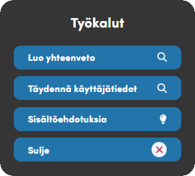
Figure 29 – Tools panel

During the discussion, you can instruct AIRRE that you would like to receive a summary of the current discussion or content suggestions. These buttons only work at certain stages of the conversation and do not need to be pressed during a normal conversation, as they are just additional tools for advanced users.
Clicking on the "Fill in user information" button will open a questionnaire where you can add your user information. This information is stored in your user profile.
Press the button to close, the tools panel will close.

Discussion
You can discuss well-being issues with AIRe. Here is an example of how AIRe discusses back pain (Figure 30). You can see your own messages on the left side of the screen and AIRRE's messages on the right side of the screen.
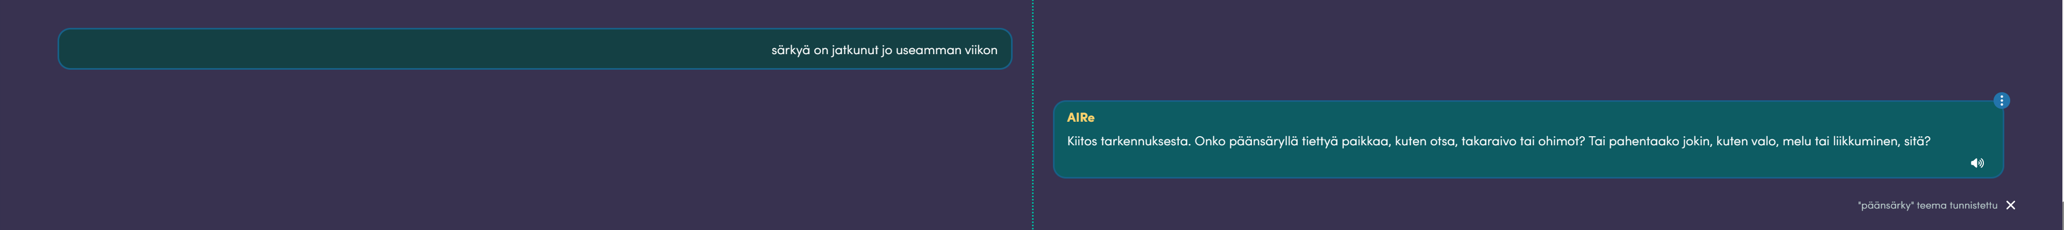
Figure 30 – Back pain discussion
You can listen to AIRRE's message by pressing the "Read message" icon in AIRRE's message box (Fig. 31).


Figure 31 - Read the posts

By pressing the "Open/close message options" icon in the upper right corner of the AIRE message (Fig. 31), you will open the message menu (Fig. 32).

Figure 32 – Open/Close Message Options

Through the message menu, you can rate the answers given by AIRR and manage individual messages:
- "I like this" – click this button if you liked AIRRE's reply.
- "I don't like this" – click this if you weren't satisfied with the answer.
- "Copy" – you can copy the message to the clipboard by pressing the button made for it.
- "Delete the following messages" - delete the conversations below that message.

Figure 33 – Message Menu
The "Delete next messages" button deletes all conversations below that message, it returns the conversation to that point. This feature allows the user to delete a part of a conversation that, for example, did not progress in the direction the user had hoped.
When AIRe detects a theme in a conversation that has been assigned to AIRe by the AIRe administrator, AIRe displays a notification in the conversation window (Figure 33). If the user thinks that the identified theme is wrong or inappropriate for them, it can be removed by clicking the X icon after the notification.


Figure 34 - Notification of Identified Theme

Once the theme has been identified, the discussion will continue normally. If AIRe notices that the discussion is not progressing or receives any new information, it will end the discussion and give a summary of the discussion. The user can also indicate that there is no more to discuss, in which case AIRe understands to end the conversation.
At the end of the discussion, AIRe will show a summary of the discussion. The user can remove the detected themes if they do not think they are appropriate.
AIRe also asks for approval for the abstract. If the user does not accept the summary, AIRe will ask more detailed questions and make a new summary based on this information.
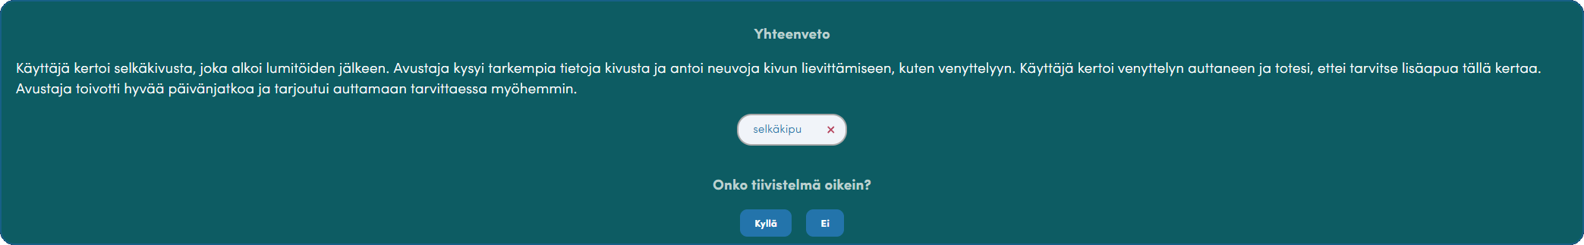
Figure 35 - Synopsis of the debate

After approving the summary, AIRe offers the user content suggestions for the observed themes, if available (Figure 36).
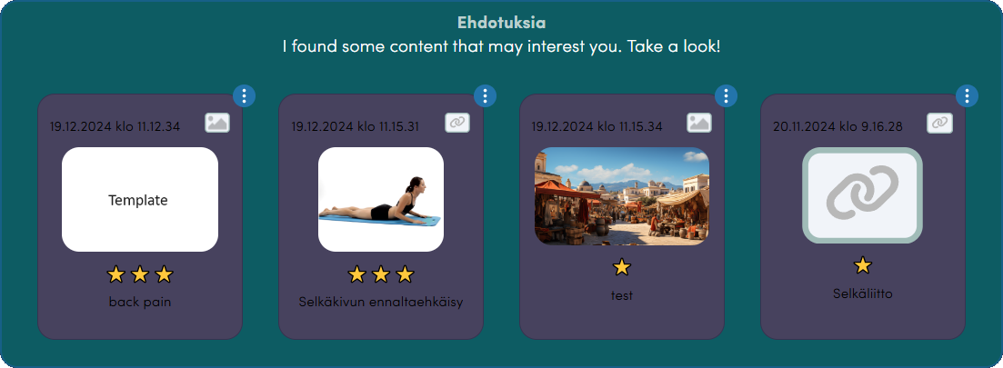
Figure 36 – Content suggestions

After the content suggestions, AIRe asks what the user would like to do next (Figure 37).
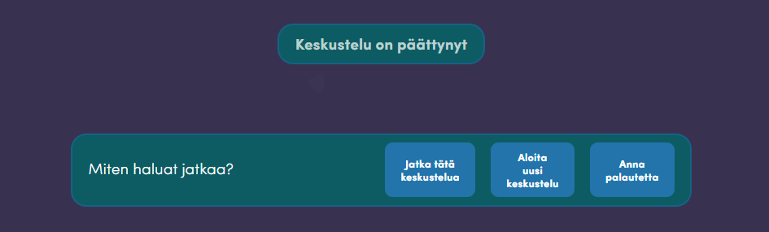
Figure 37 - How do you want to proceed to the menu
The options are to continue the same discussion, start a new discussion or give feedback on the discussion in question.

Other features

Surveys
AIRe also has surveys that can be used to find out more about a certain issue from the user. The surveys are activated automatically when there are surveys available on the theme detected by AIRE and AIRE thinks it is a good time to go through the questions. The surveys are displayed in the discussion view and the user can give their answers to them (Figure 38). After the survey has ended, the discussion will continue normally.
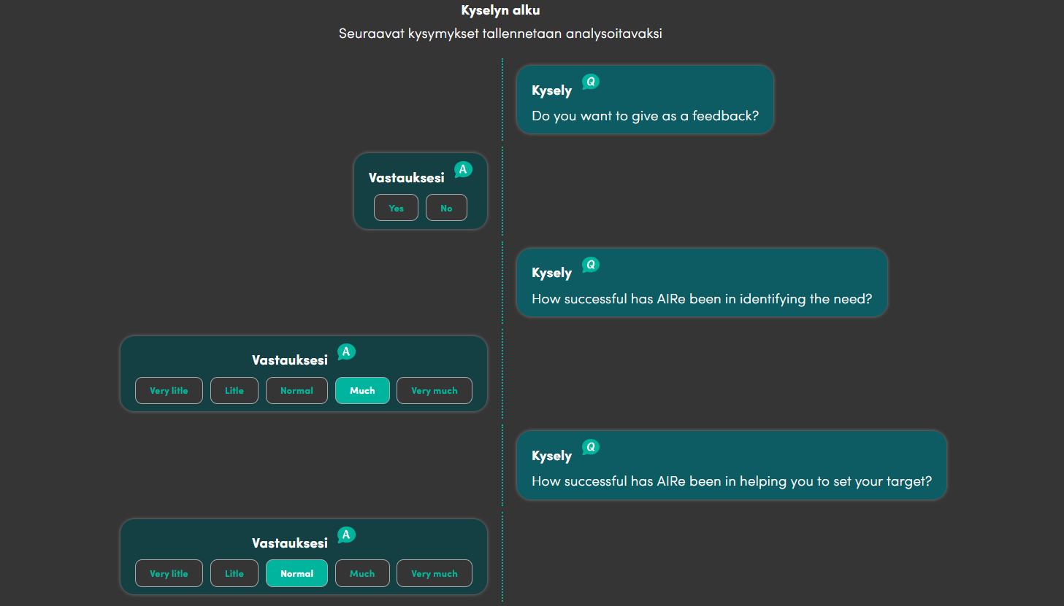
Figure 38 – Survey
Red flag questions
Some questions may be so-called 'red flag' questions. If you answer the questions so that the Red flag feature is activated, AIRe will cut off the conversation. Red flag questions are those where AIRe notices that the user's health may be endangered if they are given any instructions on the theme in question. In these cases, AIRe advises the user to contact a healthcare professional so that the situation can be safely assessed and handled.

Reminders
AIRe can remind the user. AIRe may notice something in the conversation that it would be useful to remind the user of later. The user can also ask AIRe to remind them by telling AIRe what issue they want to be reminded of later (Figure 39).
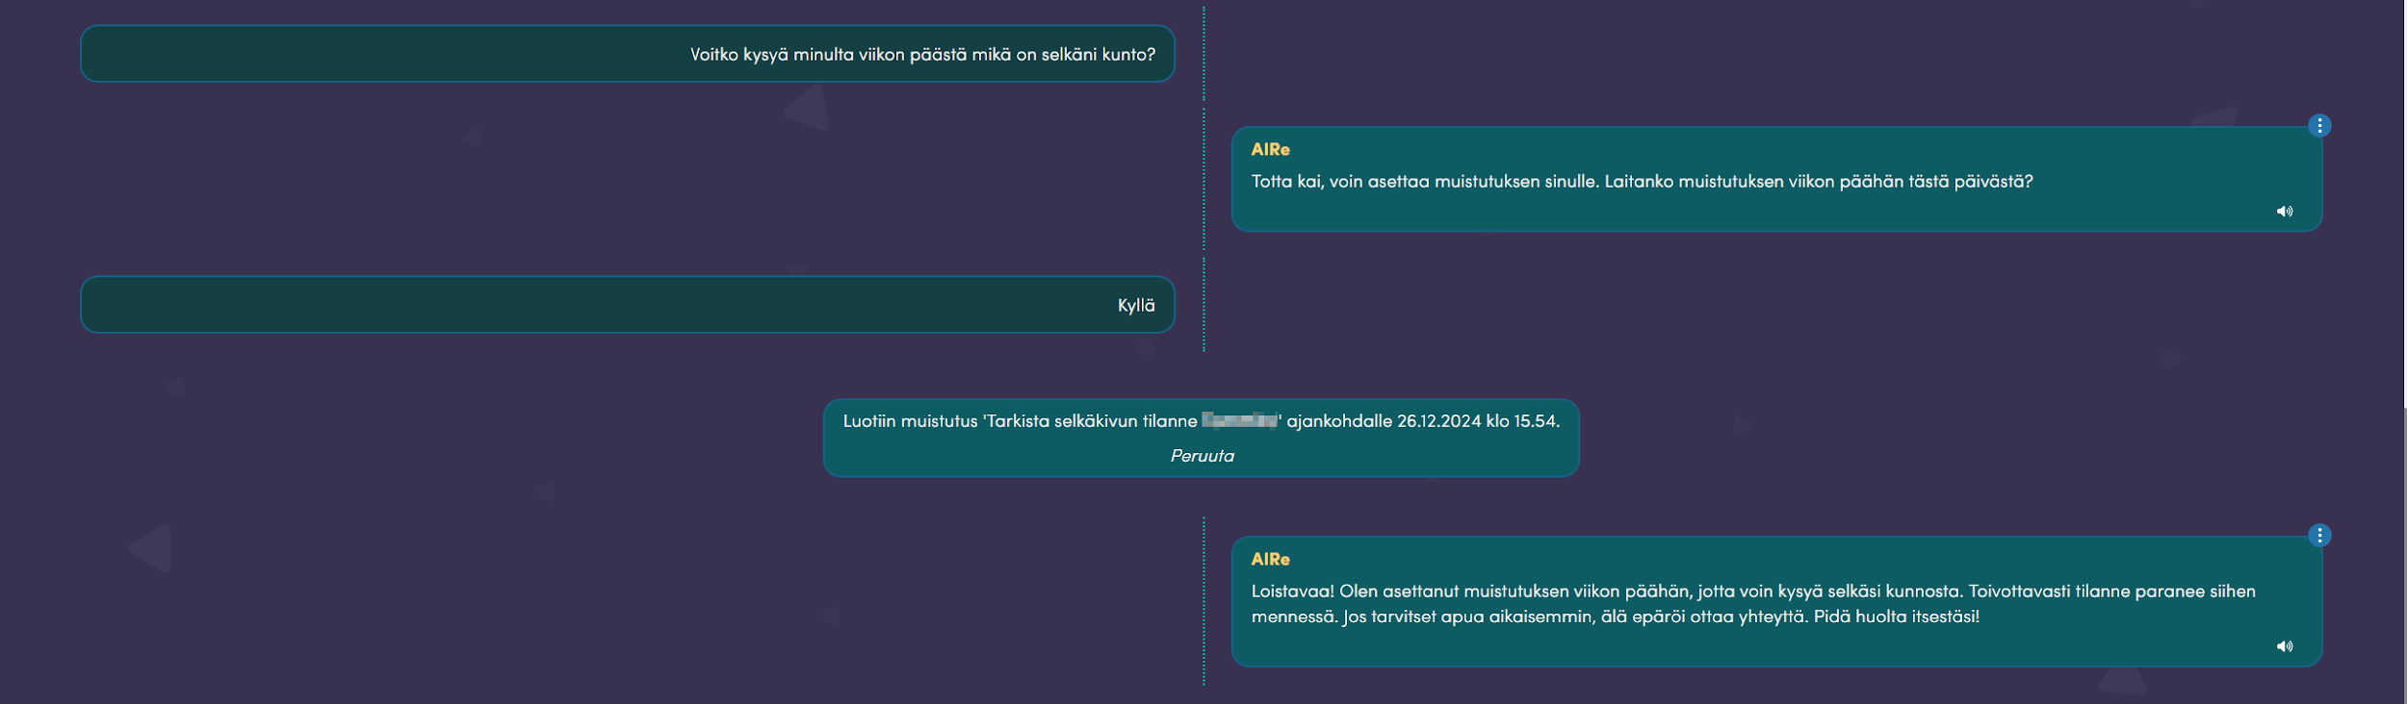
Figure 39 - Requesting a reminder
When the user logs in to AIRe and the time selected by the user is at hand, AIRe displays a reminder (Figure 40). The reminder can be returned directly to a previous discussion, or it can be marked as read. If you click on the X icon in the upper right corner, the reminder will disappear for the time being, but it will be displayed the next time the user logs in to AIR.
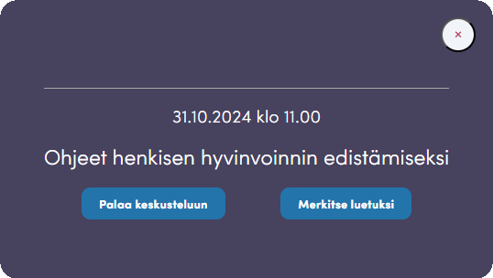
Figure 40 - Reminder

